CS 340 Project Two README

About the Project/Project Title

The Grazioso Salvare Dashboard is an interactive web-based data visualization application developed using Python Dash and MongoDB. The dashboard was created for Grazioso Salvare, a company specializing in animal rescue training, to assist in identifying suitable animals from the Austin Animal Center dataset for various types of rescue training (Water, Mountain, and Disaster).

The dashboard allows users to:

Filter animals by rescue type.

View detailed animal data from a connected MongoDB database.

Visualize top breeds in a pie chart.

Display the selected animal’s location on an interactive map.

Motivation

The goal is to apply CRUD (Create, Read, Update, Delete) operations, integrate a backend database with a frontend dashboard, and demonstrate data-driven decision-making through visualization tools. The motivation behind the project is to help Grazioso Salvare quickly identify animals with the physical and behavioral traits suited for specific rescue training programs, improving the efficiency of their selection process.

Getting Started

Make sure you have the following installed:
- Python 3.8+
- JupyterLab or Jupyter Notebook
- MongoDB (local or cloud instance such as MongoDB Atlas)

Installation

Install the required Python packages using pip:

pip install dash jupyter-dash dash-leaflet plotly pandas numpy matplotlib pymongo

If using JupyterLab, also install:

pip install jupyterlab

Make sure your MongoDB server is running and that the credentials in your CRUD module (AnimalShelter.py) match your MongoDB connection information.

Usage

Code Example
Below is a brief excerpt showing how the database connection and data retrieval work:

from CRUD_Python_Module import AnimalShelter
import pandas as pd

# Connect to MongoDB
username = 'aacuser'
password = 'JeyAndMax2025'
db = AnimalShelter(username, password)

# Read all records from MongoDB
df = pd.DataFrame.from_records(db.read({}))

# Remove MongoDB ObjectID for display
df.drop(columns=['_id'], inplace=True)

Tests
To verify database functionality, you can run simple CRUD tests in Python:

# Test database connection
print(db.read({})) # Should return a list of animal documents

# Example query test for Water Rescue animals
query = {
'animal_type': 'Dog',
'breed': {'$in': ['Labrador Retriever Mix', 'Chesa Bay Retr Mix',
'Newfoundland Mix']},
'sex_upon_outcome': 'Intact Female',
'age_upon_outcome_in_weeks': {'$gte': 26, '$lte': 156}
}
print(db.read(query))

Screenshots
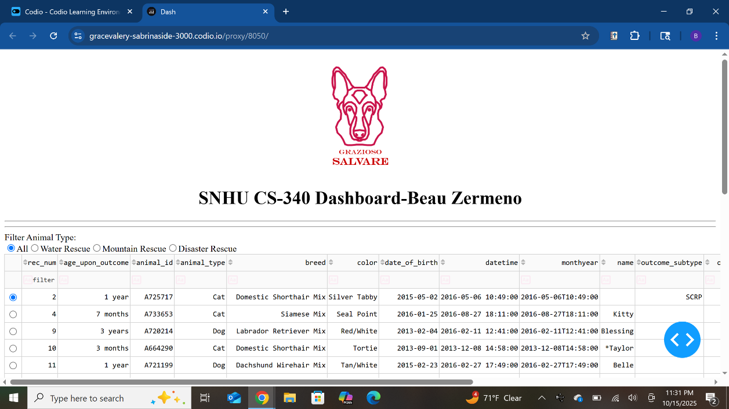

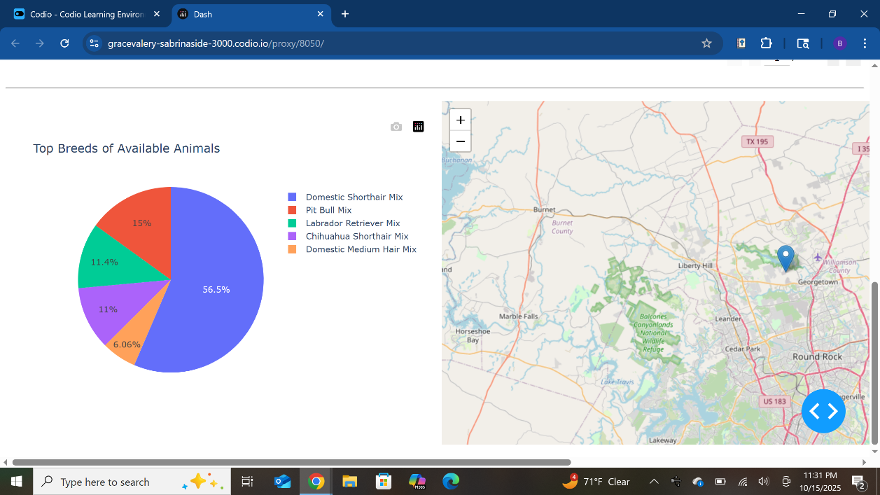
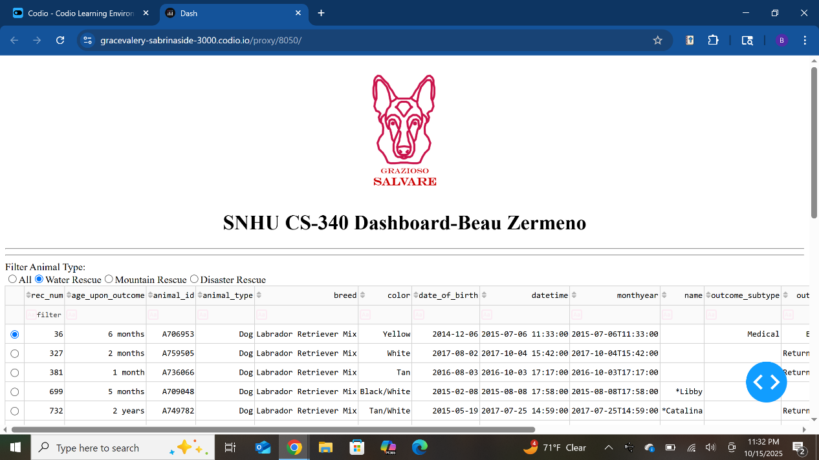

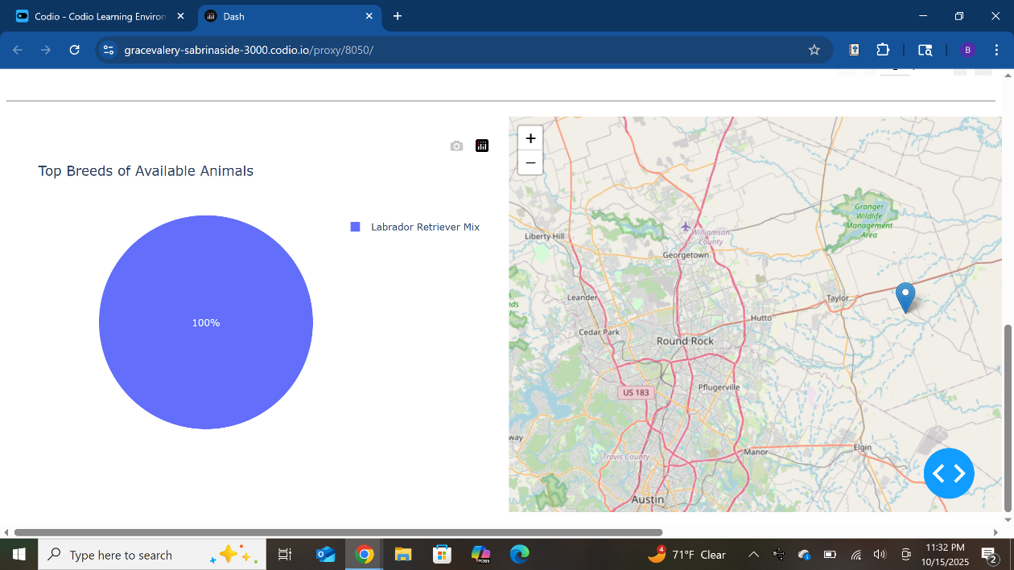

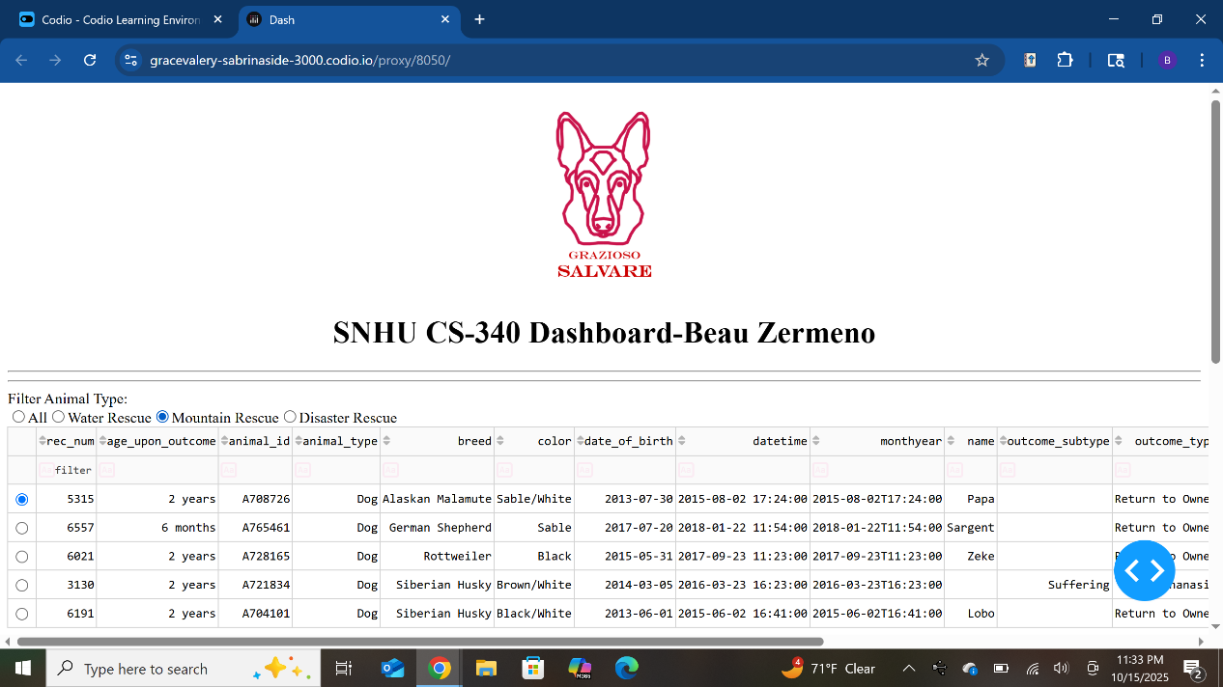

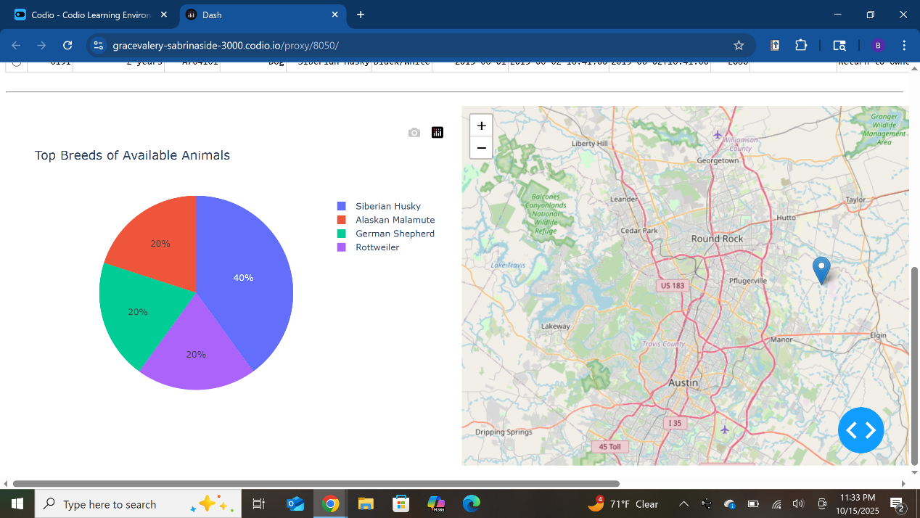

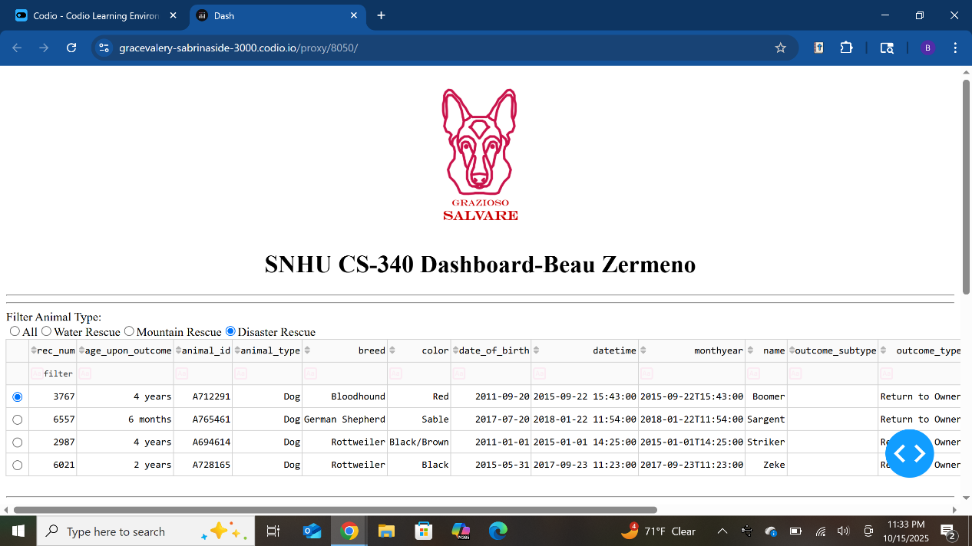

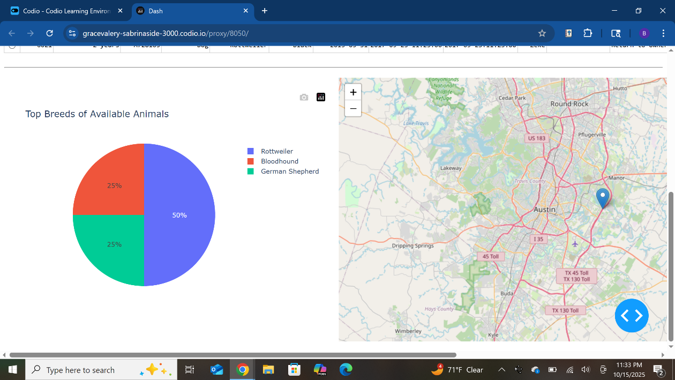

Roadmap/Features

Future improvements may include:
- Adding more interactive filters (e.g., gender, age range).
- Displaying outcome type statistics for each rescue category.
- Allowing users to export filtered datasets as CSV files.
- Implementing CRUD operations for adding or updating animal records directly in the dashboard.

Contact
Your name: Beau Zermeno

